Assignment Submission Report
Name: Sergio Gonzalez
Course / Cohort: Project 114, Cohort 65
Assignment: 2
GitHub Repository Link: https://github.com/SurgthePro/Project-114-Assignments.git

Evidence of Functionality

Frontend/UI
Attach 3 screenshots only:
- Main screen
- One interaction working
- One validation / error state

Backend/Logic
- Screenshot of one key component/element (route / controller / service)

AI Disclosure (Required) – Highlight the one that applies
- I did not use AI
- I used AI for help
- AI generated parts of my code

CustomStack Definition:
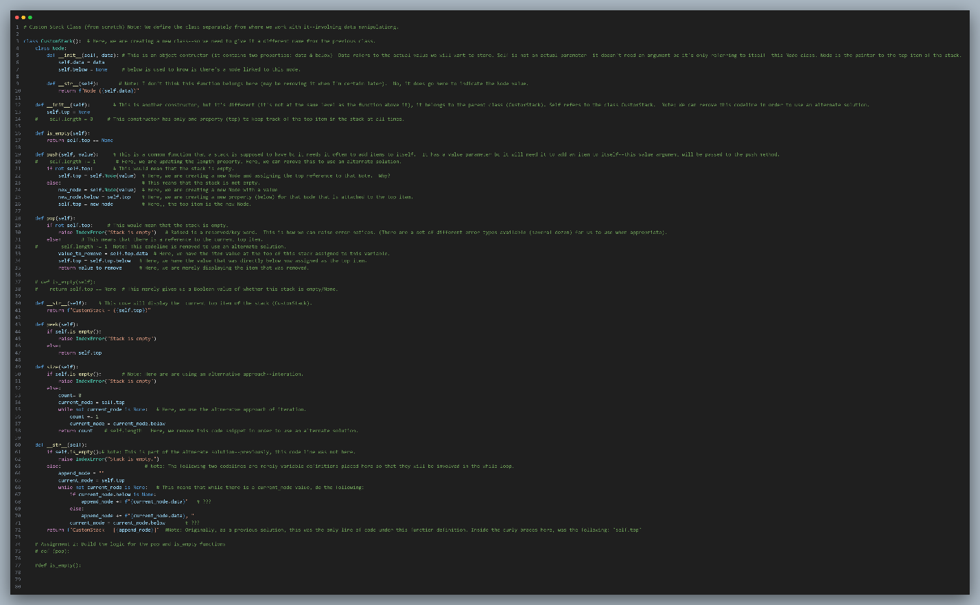

Cstack (CustomStack Instance) Solutions—Use of pop( ) and is_empty()
methods:

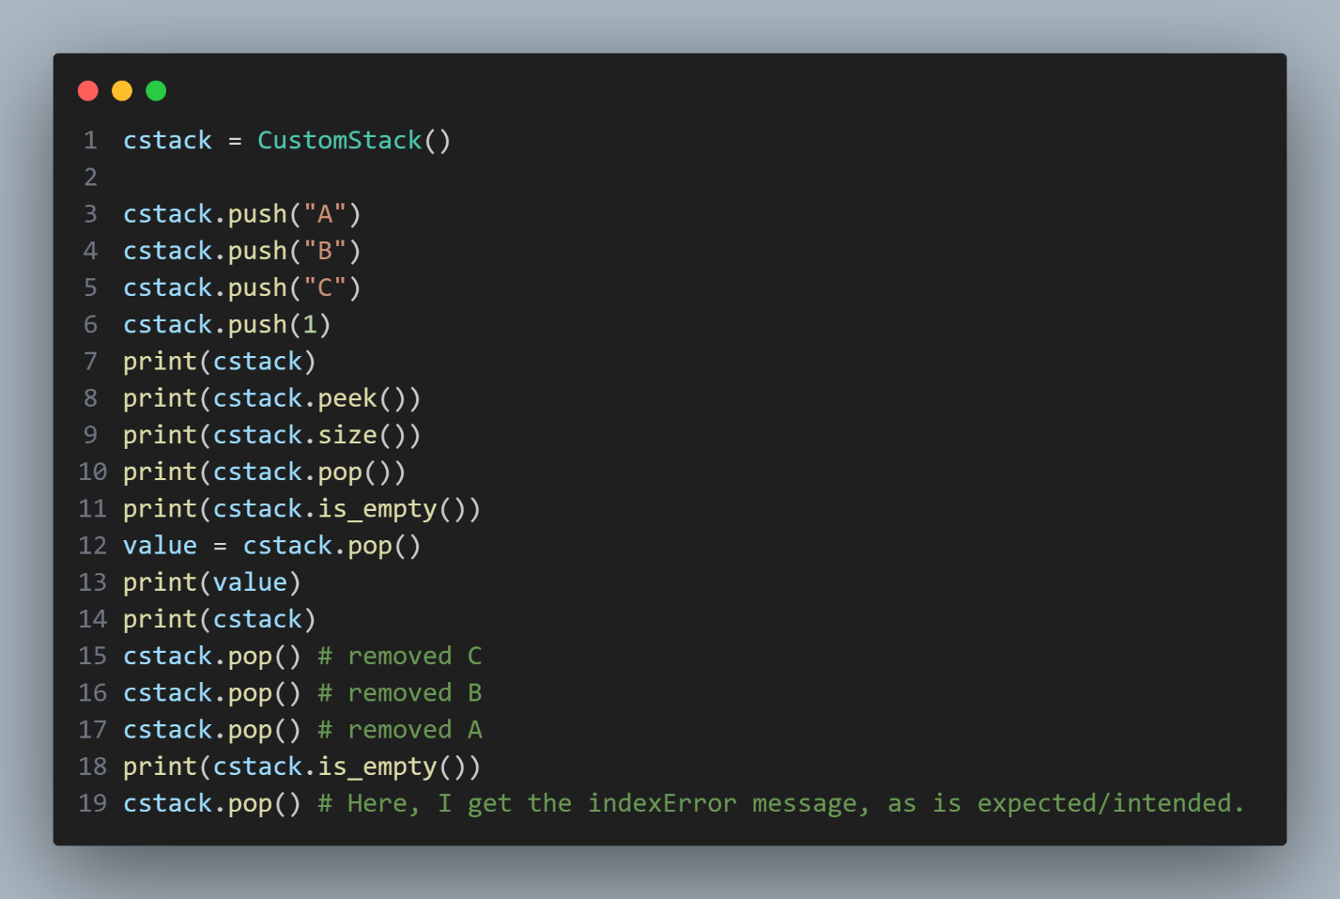

Results:

